

Software Engineering Department

Braude College of Engineering

Final Project – Phase A (61998)

**SaferTogether**

**26-1-D-21**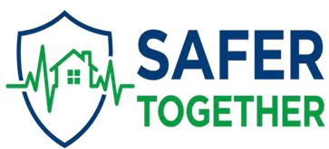

**By:**

**Bar Leibovich**

**Avner Shimon**

**Advisor:**

**Dr. Moshe Sulamy**

**Link to GitHub:**

[**https://github.com/barleibovich/SaferTogether**](https://github.com/barleibovich/SaferTogether)

**Abstract 3**

**1. Introduction 4**

1.1 Background and Problem Statement 4

1.2 The Proposed Solution: SaferTogether 4

1.3 Practice Mode and Preparedness 5

1.4 AI-Driven Affective Computing 5

1.5 Project Objectives and Criteria for Success 5

**2. Related Work 6**

2.1 Mobile Gamification for Resilience and Anxiety Reduction 6

2.2 Detection of Stress via Smartphone Telemetry (Affective Computing) 6

2.3 Real-Time Group Synchronization in Emergency Apps 7

2.4 AI and Machine Learning for Behavioral Classification 7

**3. System Requirements 8**

3.1 Functional Requirements (FR) 8

3.2 Non-Functional Requirements (NFR) 9

3.3 Development Methodology 10

**4. Requirements Gathering and Project Challenges 11**

4.1 Requirement Gathering Process 11

4.2 Expected Challenges and Risk Mitigation 11

**5. System Architecture and Design 12**

5.1 High-Level Architecture 12

5.2 System Activity Flow 13

5.3 System Activity Diagram 14

5.4 Visual Design and Mockups 15

**6. Verification and Testing Process 18**

6.1 Quantitative Success Metrics 18

6.2 The Testing Methodology 18

6.3 Comprehensive Test Cases 18

**7. References 20**

### **Abstract**

The persistent escalation of security emergencies in Israel has created a critical need for accessible management tools that assist families and educational institutions in maintaining order and psychological well-being in real-time. Currently, the process of congregating in protected spaces is characterized by informational uncertainty regarding the location of family members, heightened anxiety among children, and a lack of functional readiness due to insufficient routine training.

This project presents **SaferTogether**, a mobile-based software solution designed as an integrated educational and familial game for emergency management. The system synchronizes users in real-time, enabling rapid visual presence reporting ("Check-in") and activating a collaborative gamification module to alleviate stress once all group members have reached safety. A key innovation of this project is the integration of Affective Computing via Machine Learning algorithms. The system analyzes device telemetry data—such as touch dynamics, response latency, and motion sensors—to identify abnormal anxiety levels. This data is then processed to generate comprehensive insight reports for parents or group managers, facilitating better emotional support post-event. By leveraging real-time communication protocols and Artificial Intelligence, the system transforms the stay in protected spaces from a traumatic experience into a controlled, educational, and resilience-building process.

### 

### 

### **1. Introduction**

#### **1.1 Background and Problem Statement**

For decades, the Israeli civilian population has lived under the constant threat of rocket fire, necessitating a rapid transition from routine to emergency. While Israel has pioneered world-class physical defense infrastructure—such as the Iron Dome and regulated protected spaces (**Mamad**)—the digital landscape has lagged behind. Current technological solutions focus almost exclusively on **detection and alert**, leaving a critical gap in the "post-alert" phase. Families are often left with no structured digital tools to manage the psychological and communicative chaos that ensues the moment the siren sounds.

The transition from routine to emergency creates three critical challenges that current technology fails to address:

* **Informational Uncertainty:** High stress often renders **verbal safety confirmation unreliable.** In the heat of an alert, family members often struggle to communicate clearly via phone calls or fragmented text messages, which can be delayed or misunderstood. This lack of a streamlined, automated "check-in" system leads to secondary panic, as individuals remain uncertain about the safety of their loved ones while they themselves are under threat.
* **Acute Anxiety during Inactivity:** Home Front Command guidelines require a **mandatory 10-minute stay** in the protected space after the siren ends to account for falling debris and multiple rocket volleys. This period of "forced inactivity" is a major source of trauma. Without engagement, this time is filled with helplessness and boredom, particularly for children. Consequently, many civilians—feeling the immediate danger has passed—violate safety protocols and leave the Mamad early. There is a clear need for interactive, time-managed interventions (such as gamified timers or collaborative tasks) to ensure families remain protected for the full duration.
* **Ineffective Routine Training:** Preparedness is the key to resilience, yet standard drills are frequently perceived as boring or frightening. Because current training lacks engagement or positive reinforcement, cooperation levels often drop during actual events.

#### **1.2 The Proposed Solution: SaferTogether**

To address these challenges, **SaferTogether** is proposed as a distributed mobile ecosystem that transforms emergency management into a structured, collaborative, and gamified experience. The solution is built upon three primary functional pillars that differentiate it from standard alert applications:

1. **Preparation (Practice Mode):** Unlike standard apps that are only active during an alarm , SaferTogether utilizes a "Practice Mode" to train the family during calm periods, building positive muscle memory to prevent panic
2. **Stress Detection (AI Sensors):** The system introduces non-invasive monitoring of psychological well-being. It uses AI sensors to automatically detect high anxiety levels by analyzing touch dynamics and movement—features that standard apps cannot sense.
3. **Connection (Group Sync):** While other apps send alerts to individuals , our solution uses real-time group synchronization to keep the entire family connected and "Safe Together" via a visual status board

#### **1.3 Practice Mode and Preparedness**

A unique feature of SaferTogether is its **Practice Mode**, which addresses the lack of routine readiness. This mode allows a group administrator to initiate a "Planned Drill" during calm periods, serving several vital functions:

* **Instructional Literacy:** Users learn the interface and safety protocols without external pressure.
* **Conditioning:** By associating safety protocols with rewards, users develop positive muscle memory .
* **Hardware Baseline:** The system establishes a "Normal" interaction profile for each user, which is essential for accurate AI analysis during real stress events.

#### **1.4 AI-Driven Affective Computing**

SaferTogether introduces a sophisticated method for monitoring psychological well-being through non-invasive telemetry. Drawing from research in Affective Computing, the system tracks "Digital Biomarkers" of stress :

* **Interaction Dynamics:** Tracking erratic tapping or significant increases in cognitive errors during games.
* **Motion Telemetry:** Using the device’s accelerometer to detect tremors or rapid hand movements.
* **Latency Analysis:** Comparing response times during emergencies against the baseline established in Practice Mode.

The resulting **Stress Assessment Report** provides caregivers with data-driven insights to identify individuals who may require targeted emotional support following the conclusion of the event.

#### **1.5 Project Objectives and Criteria for Success**

The success of the project will be measured by its ability to provide a fast, accurate, and supportive environment:

* **Operational Speed:** Reducing the time required for group safety verification by at least 30% compared to traditional verbal methods.
* **Engagement:** Maintaining user participation in gamified modules throughout the 10-minute stay.
* **AI Reliability:** Achieving high accuracy in classifying distress levels through cross-referencing telemetry with Practice Mode data .

### **2. Related Work**

The development of SaferTogether is informed by a review of current market solutions, identifying a critical gap between simple alerting and active coping:

* **Pikud HaOref & Red Alert (Local Alerts):** These provide official, location-based life-saving alerts and instructions to individuals. **The Gap:** They focus on where to go, but not on how the family is feeling or if they are synced together.
* **Life360 (Family Synchronization):** Allows real-time location tracking of family members and "safe arrival" messages. **The Gap:** It focuses on passive location tracking for daily routines, but is not designed for active stress management in an emergency.
* **FEMA App (Disaster Logistics):** Includes emergency supply checklists, real-time survival instructions, and shelter locations. **The Gap:** It focuses on survival logistics and instructions, but lacks real-time synchronization or emotional support tools.
* **Help Kids Cope App (Psychological Guidance):** Provides parents with psychological scripts and tools to support children during and after a disaster. **The Gap:** It focuses on parental guidance and static scripts, lacking real-time interaction or automated monitoring.

#### **2.1 Mobile Gamification for Resilience and Anxiety Reduction**

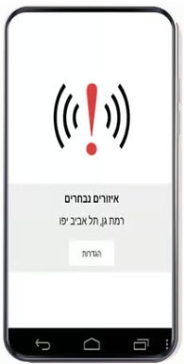Recent research has shifted from using games solely for entertainment to utilizing them as tools for psychological resilience. A study by **Roach et al. (2022)** examined how mobile-based "Serious Games" can reduce cortisol levels and subjective anxiety in high-stress environments. The study found that engaging users in "Cognitive Distraction Tasks" significantly lowers the risk of acute stress developing into long-term PTSD. SaferTogether adopts this methodology by implementing collaborative puzzles during the 10-minute mandatory wait in protected spaces, ensuring that cognitive resources are diverted from external stressors to task-oriented cooperation.

#### **2.2 Detection of Stress via Smartphone Telemetry (Affective Computing)**

A major innovation in SaferTogether is the non-invasive detection of anxiety. **Gao et al. (2020)** demonstrated that smartphone sensors, specifically the accelerometer and gyroscope, can detect "Micro-tremors" associated with acute autonomic nervous system arousal.

* **Touch Dynamics:** Research by **Vazer et al. (2021)** showed that under stress, users exhibit "Erratic Touch Patterns," characterized by increased pressure and a significant rise in "Input Latency" (the time between seeing a prompt and touching the screen).
* **Digital Biomarkers:** These findings support the use of "Digital Biomarkers" in SaferTogether to classify user distress without requiring wearable medical devices. By comparing real-time telemetry against the user's **Practice Mode** baseline, the system can identify deviations indicative of a panic state.

#### **2.3 Real-Time Group Synchronization in Emergency Apps**

The necessity for instant synchronization in life-saving applications is highlighted in the work of **Sarker & Sanyal (2020)**. Their research on "Real-time Multiplayer Gaming Architectures" emphasizes that for emergency coordination, latency must be kept below 200ms to maintain a sense of "Social Presence." SaferTogether utilizes **WebSocket (Socket.io)** technology to meet these performance standards, ensuring that a "Check-in" by one family member provides immediate visual relief to all other connected group members.

#### **2.4 AI and Machine Learning for Behavioral Classification**

Modern crisis management systems increasingly rely on supervised learning to provide actionable insights. **Banu et al. (2023)** investigated the use of **Random Forest** and **Support Vector Machine (SVM)** algorithms to classify emotional states based on mobile interaction data. Their model achieved an accuracy of 88% in distinguishing between "Calm" and "Crisis" states. SaferTogether implements a similar AI backend to process telemetry data and generate the post-event **Stress Assessment Report** for group administrators.

### **3. System Requirements**

This section details the functional and non-functional requirements of the **SaferTogether** ecosystem. The requirements prioritize rapid synchronization, psychological support, and behavioral analysis to ensure a robust response during high-pressure events.

#### **3.1 Functional Requirements (FR)**

Functional requirements describe the specific services and tasks the application must provide to the users.

|  |  |  |  |
| --- | --- | --- | --- |
| **ID** | **Feature** | **Description** | **Priority** |
| **FR-1** | **Automated Emergency Trigger** | The system must receive real-time alerts from the Home Front Command API and instantly switch all connected devices to "Emergency Mode." | High |
| **FR-2** | **Group/Family Room Setup** | Users shall be able to create a persistent "Safety Room" and invite members via a unique code to synchronize status updates. | High |
| **FR-3** | **One-Tap Check-in** | Each user shall have a prominent "I am Safe" button to notify the rest of the group of their arrival at a protected space. | High |
| **FR-4** | **Real-Time Presence Board** | The application must display a visual grid of all group members, updating their status (At Risk / Safe) with a latency of less than 200ms. | High |
| **FR-5** | **Dynamic Gamification Lock** | Collaborative games (e.g., trivia, shared puzzles) must remain locked until every member of the group has completed the "Check-in" process. | Medium |
| **FR-6** | **Practice Simulation** | Admins (parents/teachers) shall have the ability to start a "Dry Run" to practice protocols and calibrate the AI baseline. | High |
| **FR-7** | **Interactive Safety Missions** | During the gathering phase, the app shall assign micro-tasks (e.g., "Close the window," "Take a water bottle") to encourage proactive behavior. | Medium |
| **FR-8** | **Stress Telemetry Recording** | The system must record touch pressure, tapping frequency, and hand tremors via the accelerometer during interactions. | High |
| **FR-9** | **AI-Generated Report** | Post-event, the system shall provide the admin with a "Stress Assessment Report," highlighting members who showed signs of high distress. | High |

#### 

#### **3.2 Non-Functional Requirements (NFR)**

Non-functional requirements define the quality attributes and constraints of the system's operation.

|  |  |  |
| --- | --- | --- |
| **ID** | **Attribute** | **Specification** |
| **NFR-1** | **Real-Time Performance** | Status updates must be broadcasted to all group members within 200ms to prevent informational lag during sirens. |
| **NFR-2** | **High Availability** | The system architecture must be designed for 99.9% uptime, utilizing redundant cloud servers to handle nationwide traffic spikes. |
| **NFR-3** | **Intuitive UI/UX** | The interface must use high-contrast colors and large touch targets, accessible to children under stress and elderly users. |
| **NFR-4** | **Data Integrity** | Telemetry data used for AI analysis must be stored securely and deleted after the report generation to maintain user privacy. |
| **NFR-5** | **Offline Resilience** | In case of total internet loss, the app must fall back to a "Local Instruction Mode," providing pre-cached safety guidance. |
| **NFR-6** | **Scalability** | The backend must support the concurrent connection of up to 50,000 active "Safety Rooms" during a wide-scale alert. |

### 

### **3.3 Development Methodology**

The development of SaferTogether follows the **Agile/Scrum** framework, allowing for iterative testing of the real-time synchronization and AI accuracy.

1. **Requirement Gathering:** Based on interviews with families living in conflict zones to identify the primary sources of panic.
2. **Sprints:** 2-week development cycles focusing on the Real-time engine, followed by the Gamification module, and finally the AI analytical layer.
3. **User Testing:** Conducted via simulated sirens to measure the speed of "Check-in" and the effectiveness of the games in reducing heart rate (self-reported).

### **4. Requirements Gathering and Project Challenges**

#### **4.1 Requirement Gathering Process**

The requirements for **SaferTogether** were identified through a multi-layered research process designed to capture the operational needs of families and the psychological constraints of children during emergencies:

* **Stakeholder Interviews:** We conducted structured interviews with parents of children aged 5-12 and elementary school teachers. Key findings included that 90% of parents experience primary stress from "information lag"—the time spent calling family members to verify safety. Teachers noted that children often "freeze" when they have no specific task during the 10-minute wait.
* **Emergency Protocol Analysis:** A thorough review of **Home Front Command (Pikud HaOref)** documentation ensured that the "Check-in" flow and the "Missions" module align with official safety guidelines (e.g., staying away from windows, sitting on the floor).
* **Observation of Behavioral Patterns:** By analyzing testimonies from previous "Code Red" events, we identified the need for **Automated Emergency Triggers**, as users often forget to manually open apps during the initial panic.
* **Competitive Benchmarking:** Analysis of existing apps (e.g., "Red Alert") showed a gap in family-centric coordination and emotional mitigation, which helped define our project’s unique value.

#### **4.2 Expected Challenges and Risk Mitigation**

Developing a system for extreme stress scenarios presents specific technical hurdles:

* **AI Data Reliability:** Stress detection can be influenced by physical factors, such as the tremors caused by running to a shelter.
* **Mitigation:** The system records a hardware baseline during "Practice Mode" to establish a "Normal" interaction profile for each user. During a real event, the AI compares real-time telemetry strictly against this **personalized baseline** to identify genuine distress.

### **5. System Architecture and Design**

This chapter details the structural design of **SaferTogether**, focusing on its distributed nature and the high-speed synchronization required for emergency scenarios. The system follows a **Client-Server-Database** model, optimized for low latency and high reliability.

#### **5.1 High-Level Architecture**

The ecosystem is divided into three primary layers:

1. **Presentation Layer (Mobile Client):** A cross-platform application developed to run on both Android and iOS. It handles user interactions, real-time status display, and gamification modules.
2. **Application Layer (Real-Time Server):** A centralized Node.js server utilizing **Socket.io**. This layer manages the "Safety Rooms," handles bi-directional communication, and interfaces with the Home Front Command API for automated alerts.
3. **Data & Intelligence Layer:**
   * **Database:** A cloud-based NoSQL database (e.g., Firebase or AWS RDS) used for storing group structures, persistent user data, and safety logs.
   * **AI Engine:** A dedicated Python-based service that processes telemetry data (acceleration, touch pressure) using ML models to classify stress levels.

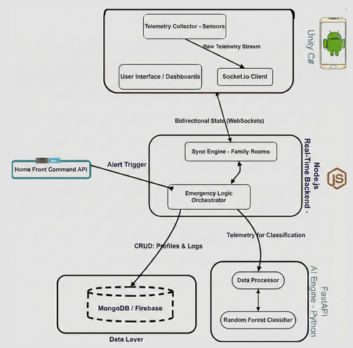

#### **5.2 System Activity Flow**

The operational flow of the system is triggered by a state change from "Routine" to "Emergency." The following diagram illustrates the sequence of events:

* **Alert Reception:** The system listens for an API signal from the Home Front Command. Once received, it broadcasts an interrupt to all active devices in the affected zones, overriding standard device functions
* **The Check-in Phase:** Users interact with the GUI to report safety. During this phase, the system begins high-frequency telemetry recording, capturing accelerometer data and touch dynamics for stress analysis.
* **Transition to Mitigation:** The logic layer checks the status of all group members. The "Collaborative Game" module remains locked until a RoomComplete signal is received from the server, ensuring all members are safe before distraction begins.
* **Post-Event Analysis:** Upon event termination, the stored telemetry is pushed to the AI engine for classification against the user's personalized baseline.

#### **5.3 System Activity Diagram**

To provide a comprehensive view of how **SaferTogether** operates across different platforms, the following **Activity Diagram** maps the interaction between the end-user, the client-side telemetry collection, and the cloud-based AI processing engine.

**The diagram defines three parallel execution layers:**

* **User Layer:** The process begins when the user receives a Home Front Command Alert or initiates a practice drill. The user follows instructions to enter the protected space and confirms their arrival, which subsequently unlocks the collaborative gaming module once the entire group is synced.
* **Device Layer (Mobile/Wearable):** Upon the alert trigger, the application auto-launches and displays immediate safety instructions. Simultaneously, high-frequency sensor monitoring (accelerometer, pulse, etc.) begins. The device performs initial noise filtering on this raw telemetry before transmitting the encrypted data stream to the cloud.
* 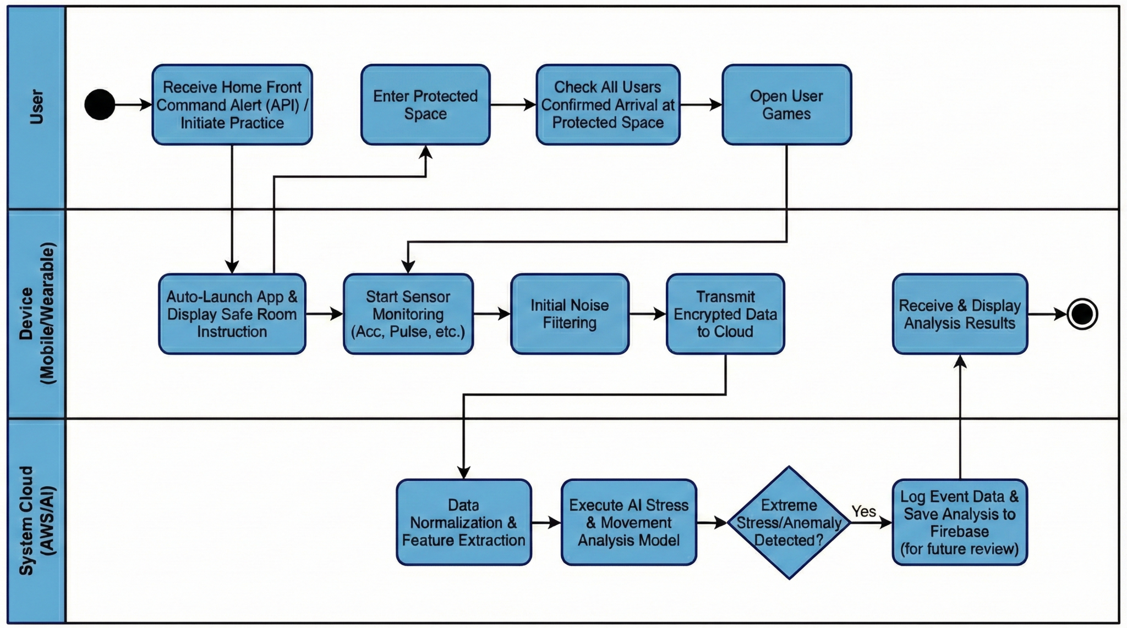**System Cloud Layer (AWS/AI):** The backend receives the telemetry for data normalization and feature extraction. The AI Stress & Movement Analysis Model is executed to distinguish between physical activity and genuine panic. If extreme stress is detected, the event data and analysis results are logged to Firebase for future review and then transmitted back to the device for real-time display to the group administrator.

#### 

#### 

#### **5.4 Visual Design and Mockups**

To ensure the system is accessible under the extreme pressure of an emergency, the interface follows **Fitts's Law**, utilizing high-contrast colors and large touch targets for "Zero Navigation".

* **Family Presence Board:** This screen provides immediate visual confirmation of each family member's status (At Risk / Safe), reducing informational uncertainty.
* **Emergency Mode UI:** Once an alert is triggered, the app auto-launches into this high-priority mode, featuring a one-tap "I am Safe" button to ensure rapid coordination.
* **Mitigation Module (Gamification):** This screen unlocks collaborative games for children only after the entire group is accounted for, providing cognitive distraction to manage stress during the 10-minute wait.
* **AI Stress Report:** A post-event dashboard for parents that visualizes AI telemetry data, comparing real-time stress markers against the personalized practice baseline.

|  |  |
| --- | --- |
| **Figure 1 : Login Screen** | **Figure 2 : Family Presence Board** |
| This screen serves as the primary entry point for the application. Users can authenticate their identity or create a new family account to access the synchronized "Safety Rooms". | This dashboard provides a group view of the family (e.g., "Cohen Empire"). It displays real-time status indicators (Online/Offline) for each family member, ensuring everyone is accounted for before an emergency begins. |

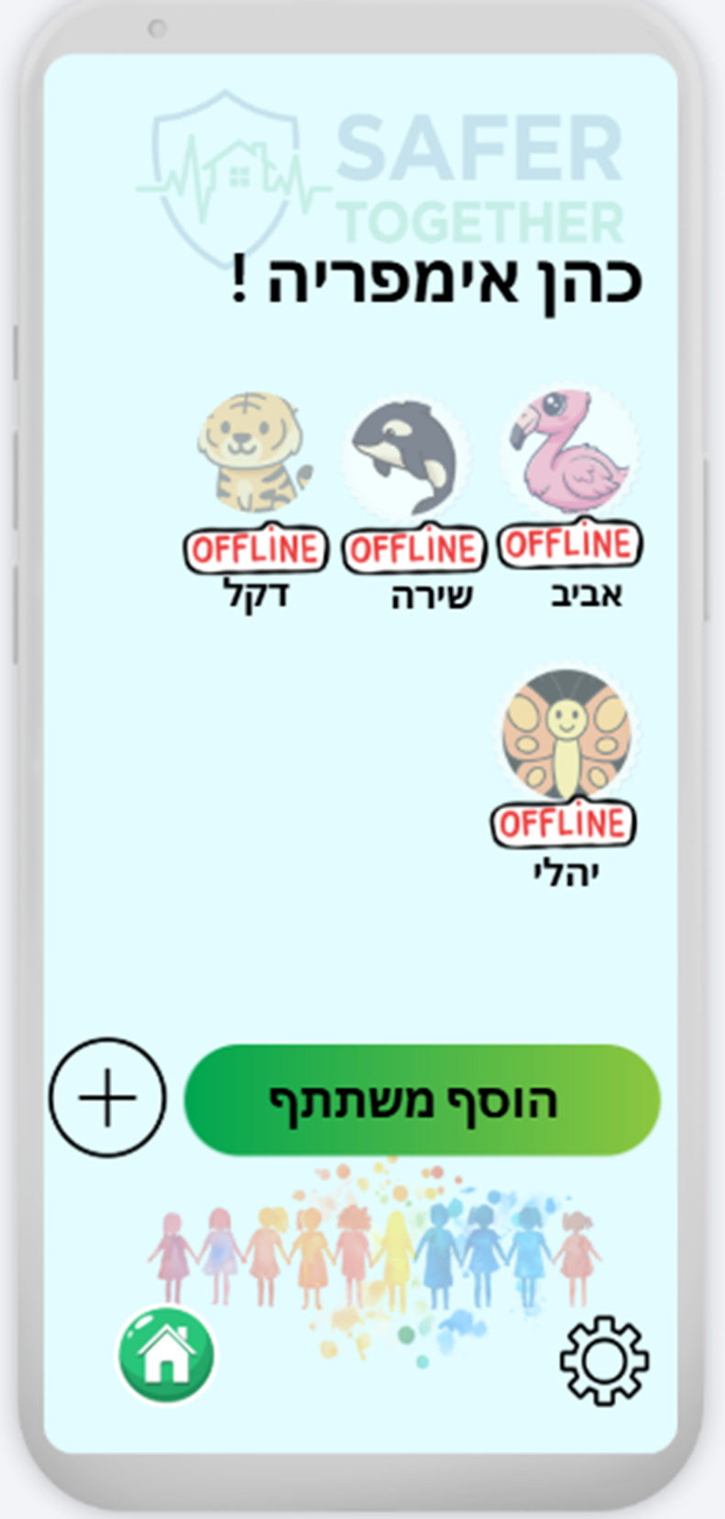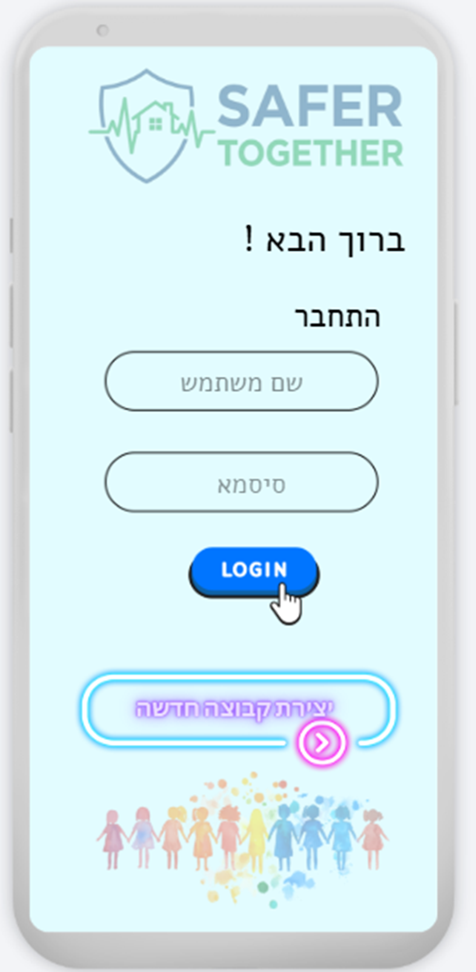

|  |  |
| --- | --- |
| **Figure 3 : Mini-Game Creation Menu** | **Figure 4 : Questionnaire Setup** |
| This interface allows the group administrator (parent) to create new content. Options include building a new trivia questionnaire or setting up a custom mission to be used during shelter stays. | Designed for proactive preparation, this screen allows parents to write specific trivia questions and define correct answers. These activities serve as cognitive distraction tasks for children during alarms. |

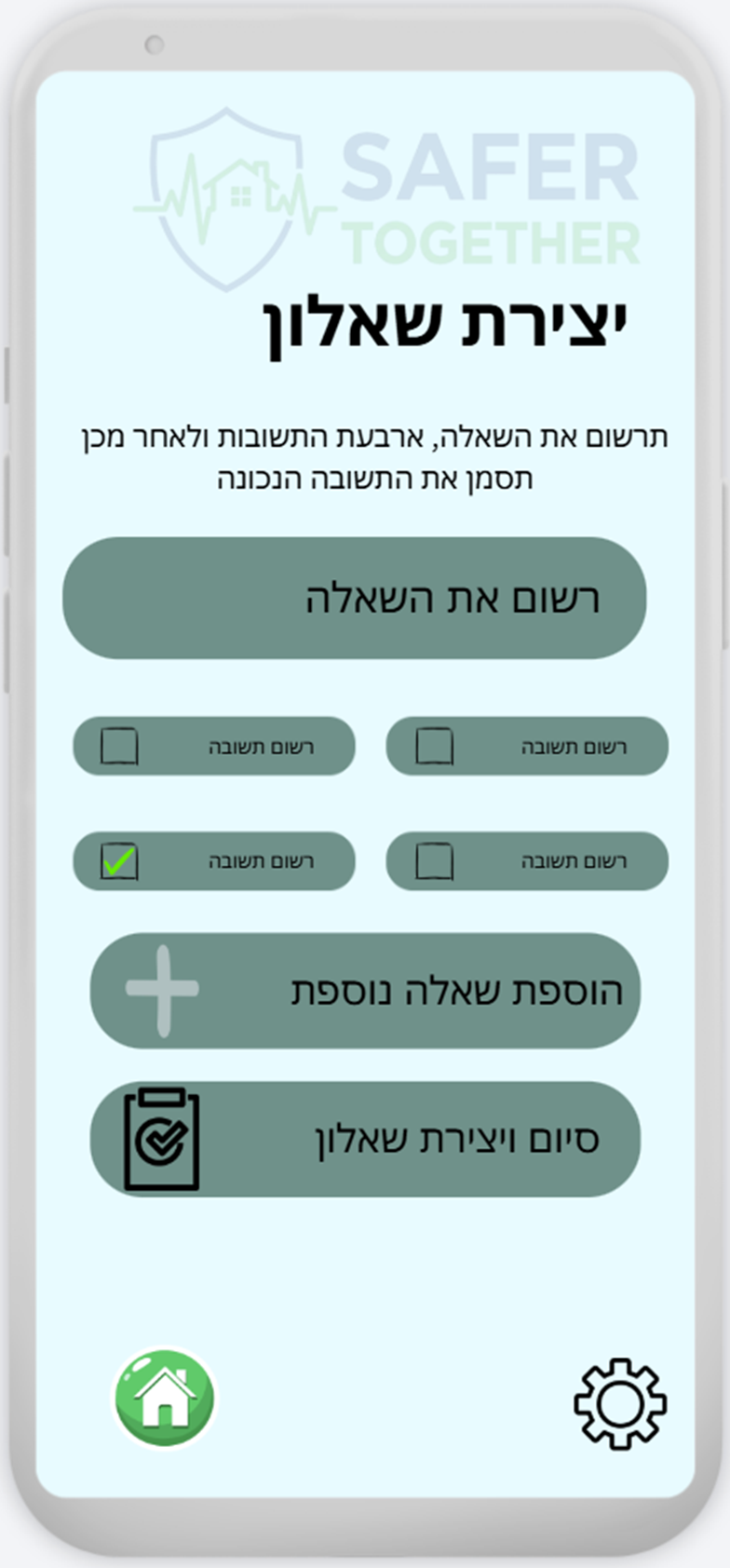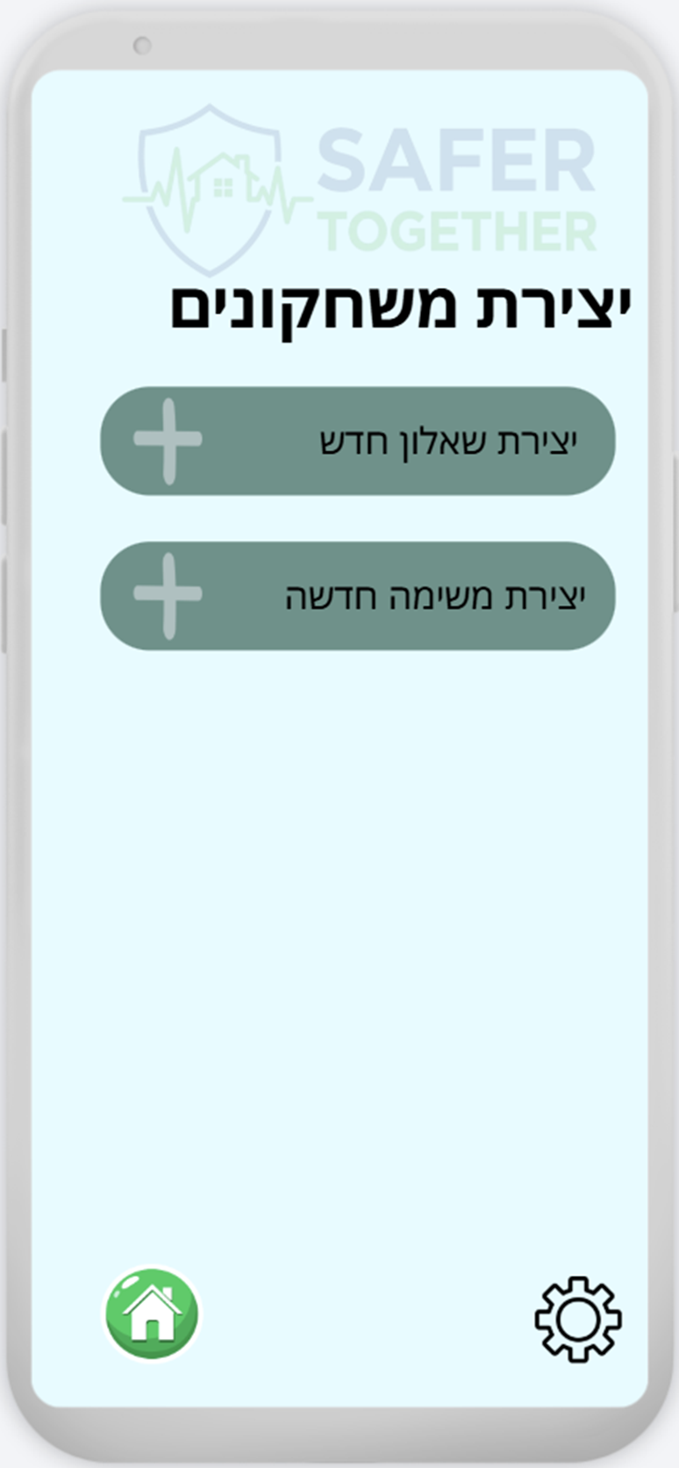

|  |  |
| --- | --- |
| **Figure 5 : Mission Interface Creation** | **Figure 6 : Emergency Mode** |
| Parents can define specific physical or digital missions, including instructions and example images. This module encourages proactive behaviour, such as bringing necessary supplies to the protected space. | Triggered automatically by official alerts, this high-contrast red interface instructs the family to enter the protected space. It features a prominent "**I am Protected!**" (אני מוגן) button for rapid, zero-navigation safety reporting. |

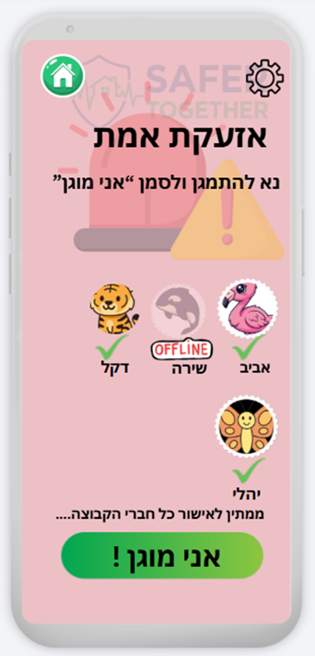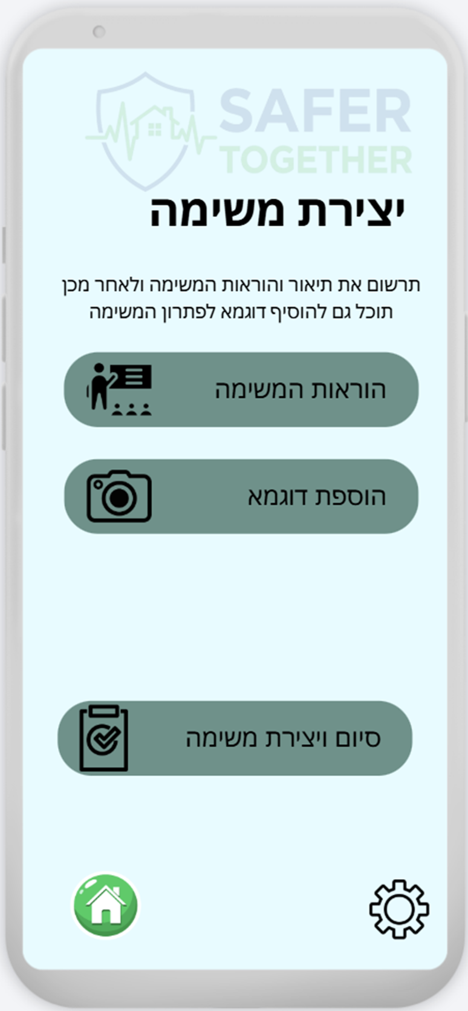

**Figure 7: AI Statistics Report**

This dashboard transforms raw sensor data into actionable insights for parents, using color-coding to identify deviations from normal behaviour: **Blue** (Practice Baseline), **Black** (Current Event), and **Red** (Historical Alarms).

* **Stress Levels by Minute (Line Graph):** Tracks the real-time **Stress Index**, allowing caregivers to identify exactly when peak anxiety occurred during the 10-minute stay.
* **Time to Answer (Bar Chart):** Compares answering speeds to detect **Cognitive Delay**; a large gap between current and baseline data indicates high mental overload.
* **Correct vs. Incorrect (Accuracy Chart):** Visualizes performance during tasks; an increase in errors during the emergency suggests a breakdown in motor skills and focus.

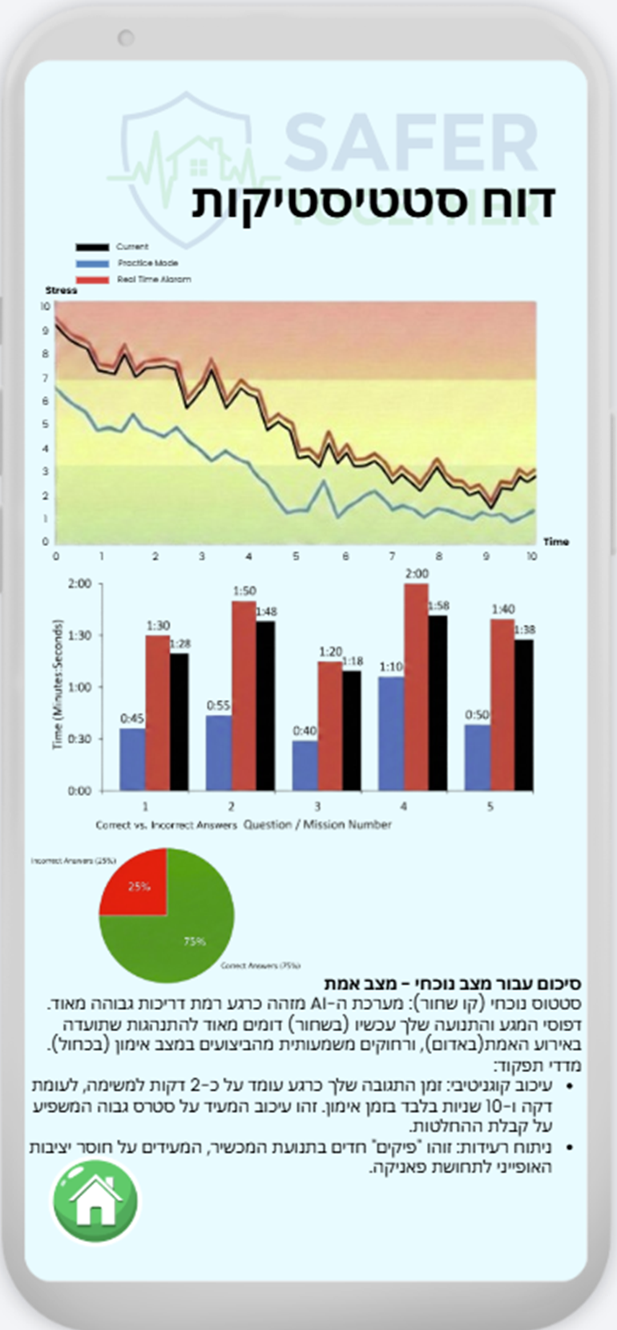The AI analyzes these **stress peaks** and **cognitive delays** to produce a summary for parents, detecting "silent trauma" in children who appear calm externally but exhibit high physiological distress.

### **6. Verification and Testing Process**

This chapter outlines the comprehensive testing strategy designed to ensure that **SaferTogether** meets its critical objectives: speed of synchronization, psychological support effectiveness, and accuracy in stress classification. Given that the system is intended for emergency use, the testing process prioritizes reliability under high-load conditions and accuracy in behavioral analysis.

#### **6.1 Quantitative Success Metrics**

To objectively evaluate whether the project has achieved its goals, the following quantitative indicators are established:

* **Coordination Efficiency:** The system must demonstrate a 30% reduction in the total time required for a family unit to verify the safety of all members compared to traditional verbal or text-messaging methods.
* **Network Latency:** Status updates (Check-ins) must be synchronized across all devices in a "Safety Room" with a latency of less than 200ms.
* **Classification Accuracy:** The AI model for stress detection must achieve a minimum accuracy rate of 85% when distinguishing between a user's normal baseline and stress-induced interaction patterns.
* **System Stability:** The backend must support a simulated load of 5,000 concurrent "Safety Rooms" (approximately 25,000 active users) without a degradation in message delivery speed.

#### **6.2 The Testing Methodology**

The testing process is integrated into our Agile development cycles, ensuring that every feature is verified before moving to the next sprint.

* **Unit Testing:** We utilize the **Jest** framework for the Web-app and **XCTest/JUnit** for the mobile clients to test individual logic components, such as the password-protection of rooms and the reward-logic for completed missions.
* **Real-Time Integration Testing:** This is the most critical phase, where we verify the bi-directional communication between the **Socket.io** server and the mobile handsets. We simulate "Code Red" API signals to ensure the automated mode-switching works across different operating systems (iOS and Android).
* **AI Model Validation (Baseline vs. Crisis):** We conduct "Dry Run" simulations where participants interact with the app in a relaxed state (to create a baseline) and then under a timed, high-pressure scenario. The resulting telemetry is used to validate the **Random Forest** classifier's ability to detect tremors and erratic touch pressure.

#### **6.3 Comprehensive Test Cases**

The following table provides a detailed breakdown of the primary test cases for the SaferTogether system:

|  |  |  |  |
| --- | --- | --- | --- |
| **Test ID** | **Module** | **Feature Tested** | **Expected Result** |
| **T-01** | **Emergency Logic** | Automated API Trigger | All group devices switch to Emergency Mode within 1 second of the signal. |
| **T-02** | **Sync Engine** | Real-Time Check-in | "Safe" status is reflected on all family members' screens in <200ms. |
| **T-03** | **Mitigation Module** | Gamification Lock | The collaborative game module remains inaccessible until every member is marked "Safe". |
| **T-04** | **Telemetry** | Sensor Data Capture | Accelerometer jitter and touch dynamics are recorded and pushed to the AI engine without data loss. |
| **T-05** | **AI Classifier** | Stress Detection | The system correctly identifies 85%+ of "High Distress" interactions based on baseline deviations. |
| **T-06** | **NFR: Scalability** | Concurrent Load Test | Server maintains response times under 200ms with 1,000+ simultaneous rooms active. |
| **T-07** | **Post-Event** | Admin Report Generation | A summary report is accurately generated and accessible to the admin within 30 seconds of the event's end. |
| **T-08** | **UX/UI** | High-Pressure Accessibility | High-contrast buttons and one-tap interfaces are correctly rendered and responsive on all screen sizes. |

### **7. References**

1. **Banu, S., et al. (2023).** Machine Learning Models for Real-time Emotional Classification using Mobile Telemetry. *MDPI Sensors*.
2. **FEMA App.** Federal Emergency Management Agency. Includes emergency supply checklists and real-time survival instructions.
3. **Gao, Y., et al. (2020).** Predicting User Stress Levels Through Smartphone Interaction and Sensor Data. *IEEE Transactions on Affective Computing*.
4. **Help Kids Cope App.** Providing parents with psychological scripts and tools to support children during and after disasters.
5. **Life360 App.** Life360 Inc. Real-time location tracking and safety communication platform.
6. **Pikud HaOref (Home Front Command) App.** Israel Defense Forces official alert and emergency instruction application.
7. **Roach, G. D., et al. (2022).** The efficacy of mobile gaming as a cognitive vaccine against anxiety during environmental crises. *Journal of Digital Health & Psychology*.
8. **Sarker, A., & Sanyal, S. (2020).** Architectures for Real-time Multiplayer Gaming: Reliability in Distributed Systems. *Journal of Network and Computer Applications*.
9. **Vazer, M., et al. (2021).** Touch Dynamics as a Proxy for Cognitive Load: A Study in Emergency Response Interfaces. *International Journal of Human-Computer Studies*.